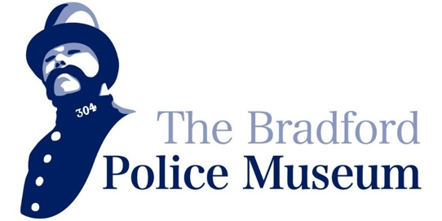

Project Title: Educational Programme Scoping Project

Background

The Bradford Police Museum is an Accredited, volunteer-led museum located within Bradford City Hall. It preserves and shares the history of policing in Bradford and is committed to improving access to its collections through learning and engagement.

Developing a sustainable educational programme is a key priority within the museum’s Forward Plan (2024–2027). Initial pilot activity, including partnership work with the National Literacy Trust, has demonstrated strong demand from schools and young people, particularly through interactive, museum-based learning. However, this provision has developed organically and is currently limited by reliance on volunteer capacity and informal delivery models.

The museum has established an initial framework for expanding its educational offer. It is now seeking to strengthen this foundation through professional input, ensuring that the programme is robust, evidence-based, and deliverable within the organisation’s capacity. This project represents a critical development phase, designed to inform a future National Lottery Heritage Fund project - Heritage Connections - which will focus on piloting and embedding the programme from early 2027.

Wider Context

This project is a key step in the museum’s long-term development. It will inform a future project to establish a part-time Educational Facilitator role, increase staff capacity, and create a sustainable model for delivering educational activity.

It will also support the development of the museum’s volunteer workforce by creating structured opportunities for skills development in heritage and museum education, helping to attract and retain volunteers interested in this area.

Project Purpose

The purpose of this project is to transform an existing outline educational programme into a clearly defined, evidence-based, and deliverable model. The appointed consultant will work collaboratively with the Museum Manager, volunteers, and stakeholders to:

- strengthen the museum’s existing programme framework
- ensure it is grounded in audience need and sector best practice
- develop realistic delivery models aligned with organisational capacity
- produce a costed and structured programme ready for future funding

Scope of Work
The consultant will be expected to deliver the following:

- Review & Analysis
- Review existing educational activity and materials
- Assess the current programme framework
- Identify strengths, gaps, and opportunities

- Audience & Stakeholder Engagement
- Engage with key stakeholders (e.g. teachers, education partners)
- Identify priority audiences and their needs
- Explore barriers to engagement and access

- Programme Development
- Develop a structured educational programme, including:
  - school workshops
  - outreach/in-school learning
  - family and school holiday sessions
- Define session formats, delivery approaches, and learning outcomes

- Delivery & Workforce Model
- Develop realistic delivery models based on:
  - limited staff capacity
  - supported volunteer involvement
- Define the role of a future Educational Facilitator
- Recommend approaches to volunteer engagement, support, and training

- Resource Development
- Scope learning resources such as:
  - classroom packs
  - digital learning materials
- Ensure resources are practical, accessible, and reusable

- Sustainability Planning
- Develop a balanced model of:
  - income generation (e.g. school visits)
  - free and accessible provision
- Contribute to a costed programme framework

- Final Outputs
The consultant will produce:
- A structured Educational Programme Framework
- Defined delivery and staffing model
- Audience and engagement insights
- Resource development plan
- Costed programme outline
- Final Scoping Report to inform a future NLHF application

Key Deliverables

- Educational Programme Framework
- Delivery Model & Staffing Plan
- Audience Insights Summary
- Resource Plan
- Costed Programme Outline
- Final Scoping Report

Timescale

- Project duration: 8 weeks
- Project Dates: Monday 15th June 2026 – Friday 7th August 2026

The consultant will be expected to work flexibly across this period, combining on-site engagement with remote working.

Project Management

The consultant will report to the Museum Manager and will work closely with:
- museum volunteers
- education stakeholders
- external partners where relevant

Regular check-ins will be agreed at the start of the project.

Person Specification
The museum is seeking a consultant with:

Essential:
- Experience in museum or heritage learning programme development
- Strong understanding of education and engagement practice
- Experience working with schools and young audiences
- Ability to develop practical and deliverable programme models
- Strong communication and facilitation skills

Desirable:
- Experience working with small or volunteer-led organisations
- Knowledge of inclusive practice and widening participation
- Experience of NLHF or similar funding environments
- Experience developing learning resources

